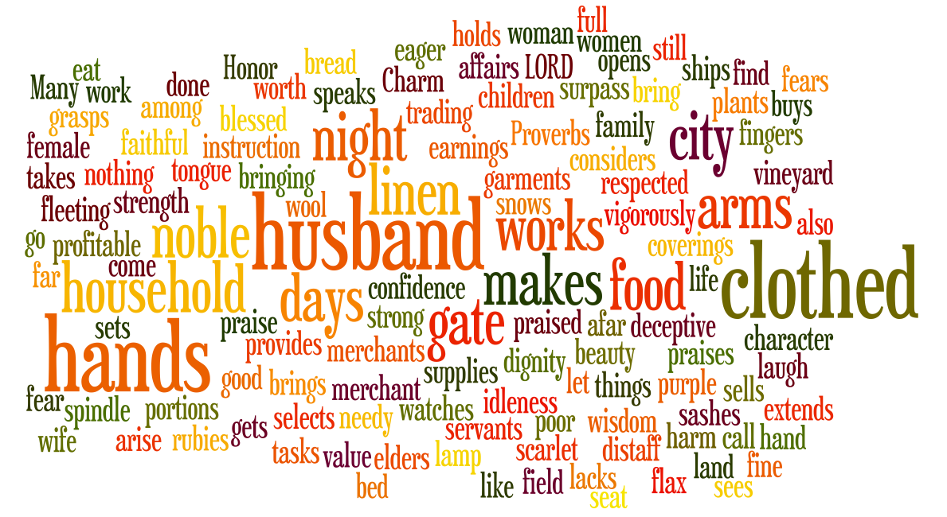
The Proverbs 31 woman…

…and me

Saturday 18th May 2024

Talk
Introduction:

1. Getting to know Proverbs

a) Literature

b) Purpose

2. Getting to know the Proverbs 31 woman
a) Her value (vs. 10-12)

b) Her life (vs. 13-27)
(i) What she does
Mind (vs. 16,18,21)

Hands / arms (vs. 13,19,22,24,20,17,15,18,27)

Mouth (vs. 26)

(ii) Why she does it (vs. 30, see also Prov 14:31, 31:25)

c) Her reward (vs. 28-31)

3. Why the Proverbs 31 woman is here

4. The Proverbs 31 woman and me

Conclusion

Small Groups

Summary of what we learnt about the Proverbs 31 woman
- The fear of the Lord, shapes
  - what she does (serves with her mind, hands and mouth)
  - who she serves (husband, children, household, community)
  - how she does it (godly character)
But she points beyond herself to Jesus, the wise one par excellence! He is the fuller & richer picture (and reality) of what wisdom looks like with flesh on. Let’s now think about what all this means for us as Christian women.

1. What can you think of in the NT that reinforces this picture of the Proverbs 31 woman? Ie. what qualities of women are celebrated as the godly ideal? Think about them in the following categories

- What she does (ways of using her mind, hands and mouth)

- What relationships are a priority & what serving them looks like

- What aspects of godly character are affirmed

2. How do the following passages help shape what wise living might look like for us? James 3:13-18, Ephesians 5:15-21?

3. Write out a modern description of the Proverbs 31 woman
Now is the time for some fun! Spend some time consolidating everything we’ve learnt by transforming the Proverbs 31 woman into a Christ-like embodiment of wisdom & womanhood.

4. Group presentations (:

Submit any questions you have at slido.com, meeting #1415272
Notes

Personal application, sharing & prayer

- In light of all this (what the modern wise woman who fears God looks like), can you see any priorities in your own life which might need re-arranging, given the circumstances, responsibilities God has given you?

- In light of this, what areas of your character/attitude do you want / need to grow in?

- What kinds of things will hinder you from growing to be this kind of woman? What kinds of things will help you?

- Please spend the last 15 minutes praying for one another in light of your new understandings and commitments to change/grow.

